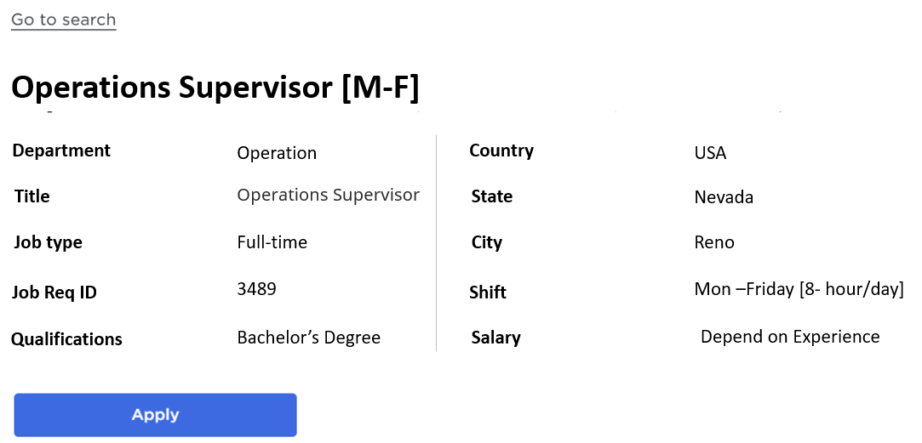

Quant Quality LLC’s mission is to continually raise the bar for customer service by providing quality inspection and real-time data-sharing technology to solve complex problems in manufacturing.

We are a global provider of quality assurances including sorting, inspection, rework, repair, New Product Launch & on-site quality representation in Automotive, Electronics, and other industries.

**Roles & Responsibilities:**

* Oversee the availability of materials, the flow of supplies, and manpower in all projects and inspection areas to ensure the achievement of productivity and shipping goals.
* Manpower allocation to all open projects and make sure products are delivered to customers on time with zero defects.
* Responsible for inspection floor 5S, Kaizen, Lean Manufacturing, and Operational Excellence activities to improve the overall efficiency of business units.
* Process all direct report timecards and ensure all associates are completed.
* Establish and maintain facility standards for safety, productivity, reliability, and accuracy. Ensures all established policies and procedures are followed by employees.
* Monitor the work performance of each employee to ensure that quality and quantity expectations are met or exceeded. Reward and recognize associates monthly for performance above and beyond expectations.
* Administer policies/procedures in a fair and consistent manner. Professionally address HR-related issues with employees utilizing the proper resources.
* Understanding of quality control measurement tools such as vernier, micrometer, height, depth, torque wrench, G0/NO-GO, and other gauges.
* Provide ongoing training/retraining of employees to ensure that they are prepared to meet or exceed the quality standards for their functions.
* Performed layered process audits, quality, and safety audits to ensure the inspection area is meeting the company standards.

**Education**

* Associate degree or High School diploma or equivalent.
* Preferable Education: MBA, Bachelor’s degree, Engineering, and Management.

**Work Experience**

* 1 year of experience in a technician, engineering, or project management field.

**Job requirements:**

* Must wear steel-toed boots, safety glasses, vests, and use gloves when inspecting materials.
* Statistical and data analysis skills
* Strong communication skills
* Drug screen & background check required

**Benefits:**

* Training for automotive quality standards, and utilization of quality control tools
* Excellent growth and advancement opportunities
* Team-based culture that rewards individual and department performance

**This privacy policy (“Policy”) describes how Quant Quality LLC in Nevada (“Company,” “we,” and “our”) processes, collects, uses, and shares personal data when using this website http://quantquality.co (the “Website”). Please read the following information carefully to understand our practices regarding your personal data and how we will process data.**